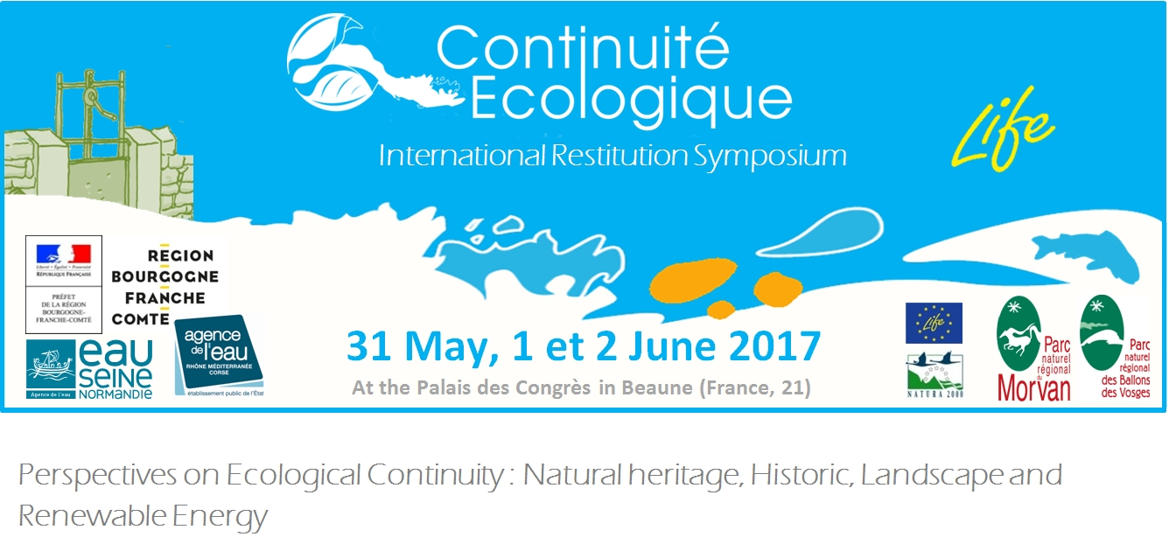
Simplified program

For centuries, weirs have been built across rivers to use water energy or create fishponds. Thus the rivers are marked by the development of numerous structures which split them and create a break in ecological continuity.

In order to respond to this issue, the regional natural Parks of the Morvan and the Ballons des Vosges have joined together to the Life program "Ecological continuity, watershed management, and associated heritage fauna". With their partners, they now wish to share their experiences through an international symposium on 31 May and 1 and 2 June 2017 in Beaune (FRANCE, 21).

The simplified program is as follows:

 | Wednesday 31 may |  | Thursday 1 june | Friday 2 june
9h | Theme 1 (Plenary): What are the impacts of breaking ecological continuity on the aquatic ecosystem? |  | Theme 3 (Plenary): How ecologically and sociologically acceptable restoration projects of ecological continuity can be carried out? | Field visits
 |  | Theme 2 (Plenary and workshops): What tools or animation techniques can be used to explain ecological continuity? | Collective synthesis of workshops
 |  |  | Theme 4: Which tools of animation of territory make it possible to initiate or perpetuate the actions of restoration of the ecological continuity?
 | Workshops : ecological continuity, small hydropower, heritage and landscape.
18h |  |  | Conclusion, round table and closing of the symposium
The fragmentation of natural environments affects all ecosystem balances. The obstacles present on rivers induce disturbances varying according to their height, their location and the cumulative effect of their succession.
Theme 1 (Plenary session): What are the impacts of the break in ecological continuity on the aquatic ecosystem? Examples of scientific work in France and on an international scale. How can these impacts be quantified before and after work? Apart from improving the aquatic ecosystem, what are the other expected benefits of restoring ecological continuity (resilience to climate change, etc.)?
The restoration of ecological continuity on watercourses is now a major issue in the European Water Framework Directive (WFD) and its declensions in french laws. However, these new regulations are difficult to implement. The historical, landscape and cultural heritage of the weirs are the main reasons for this. Moreover, the evolution of technologies and the development of renewable energies stand up for reflection on small hydroelectricity. To this day, the restoration of ecological continuity is at the heart of the debate and raises a lot of concerns from the riverside owners, elected officials and other users of our rivers.
Workshops (and collective synthesis of workshops):
- Ecological continuity and small hydroelectricity: Is profitability the aim sought-after a property owner? From what production threshold can we say that hydroelectric production becomes of general interest? What is the balance between the level of ambition of restoring ecological continuity and maintaining the hydro-energy potential?
- Ecological continuity and historical heritage: Which elements make it possible to qualify a threshold of historical heritage? Does the loss of the body of water generated by a weirs devalue the built heritage? What is the balance between the level of ambition to restore ecological continuity and the preservation of the historical heritage?
- Ecological continuity and landscape: Which factors determine our preference between a water body and a current river? Are weirs a determining factor in our landscape? What is the balance between the level of ambition to restore ecological continuity and the maintenance of the landscape?
Accompanying this evolution appears as a central and long-term communication issue. It should also be pointed out that this notion of a break in ecological continuity is very complex : it brings together many ecological concepts of watercourses. A better understanding of these mechanisms by the general public and a deeper appropriation of problems of loss of biodiversity will undoubtedly favor a better way of dialogue.
Theme 2: Which methods, tools or techniques of animation are most effective to explain the notion of ecological continuity? Which audience should be targeted? How can academic program be linked to the notion of ecological continuity?
This public policy cannot therefore be reduced to the technical dimension alone. They also have philosophical, sociological and political dimensions. Since the implementation of these directives, several examples of restoration exist. It is possible to propose environmentally and sociologically acceptable solutions. We must rely on functional examples in France and abroad.
Theme 3: What are the psychosocial restraints to the restoration of ecological continuity? Concrete examples of restoration of ecological continuity, taking into account the heritage, landscape and economic stakes, in France and abroad.
The question of the relationship between man and nature is therefore at the heart of the debate and the subject of water policies. Given the difficulties in implementing policies to restore ecological continuity, improvements should be considered to optimize the implementation of plans and programs.

Theme 4: What is the state of progress of the policy of restoration of ecological continuity in France? How are these policies dealt with abroad? What are the inputs of water policy (GEMAPI, SAGE, TVB ...)? How to develop links between actors?

We therefore hope that this symposium will summarize the issues related to ecological continuity, the difficulties of implementation and the levers for the success of the projects. To know, to reconcile, to act and to communicate, is the method that has been used in the Life program "ecological continuity" and we also want to share it through field visits. Several weirs of mills with different levels of ambitions and stakes will be visited. The constraints related to each sites will be exposed. A pedagogical trail incorporating an interactive model will close the field visits.

* The symposium will be translated simultaneously into French and English.

