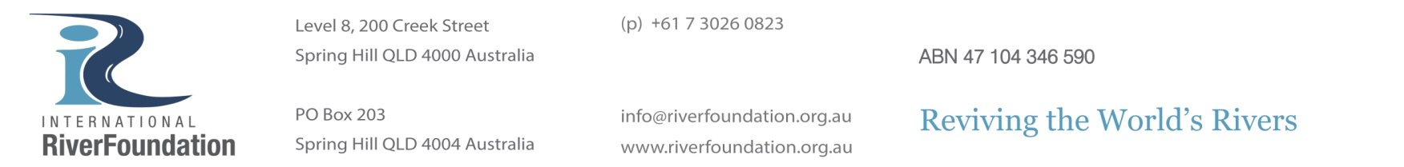
MEDIA RELEASE
4 March 2016
SPAIN’S SEGURA RIVER AWARDED TOP PRIZE FOR
RIVER RESTORATION IN EUROPE

The Segura River of Spain has just been named the winner of the International RiverFoundation’s 2016 European Riverprize.
The International RiverFoundation (IRF) presented Mr Miguel-Angel Rodenas, President of the Segura River Basin Authority, with the award at a gala dinner held at Vienna City Hall on Thursday 3 March, recognising the river’s extraordinary return to health following extensive restoration efforts over the past thirty years.
The Segura River Project has successfully restored the health of the river, with advanced wastewater schemes now supplying reclaimed water to the agriculture industry which rapidly boomed after Spain became a member of the European Union. This once polluted and water-stressed river in Europe’s driest basin has been transformed from an exposed sewer to a healthy, vibrant river, home to otter, migratory birds, and other flora and fauna, and the reuse of irrigation water has allowed increased agricultural, leisure and recreational activities.
Mr Bart Fokkens, Chair of the IRF European Riverprize judging panel and Chair of the European Centre for River Restoration, congratulated those who contributed to reviving the Segura River and praised their holistic approach.
“The Segura river management is a great example of an integrated approach with environmental, social and economic restoration activities. The established management framework includes a solid science foundation and shared governance, while the catchment management planning process was ahead of the European legislation requirement. These demonstrated innovations created almost a miracle under the scorching sun of Spain!”
The IRF European Riverprize is awarded annually for outstanding efforts in river management, restoration and protection, and the Segura River was selected over the Aragon River (Spain) and the River Trent (UK) who were also finalists for the prestigious prize.
The Segura River will now automatically qualify for stage two of the renowned Thiess International Riverprize in 2016, awarded to those who demonstrate world’s best practice in sustainable river basin management, restoration or protection. The 2016 Thiess International Riverprize will be awarded at the 19th International Riversymposium in New Delhi, India, on 13 September.
In 2014, Europe’s River Rhine went on to win the coveted Thiess International Riverprize, worth AU$300,000, after first being awarded the IRF European Riverprize in 2013.

Ends.

Contact:
Patricia Dalby, Marketing and Communication Manager, International RiverFoundation
+61 410 214 613 | patricia@riverfoundation.org.au

